Abbreviations

|  |  |
| --- | --- |
| AMI | Amazon Machine Image |
| AZ | Availability Zone |
| EBS | Elastic Block Storage |
| EC2 | Elastic Compute Cloud |
| IAM | Identity Access Management |
| NACL | Network Access Control list |
| S3 | Simple Storage Service |
| SSH | Secure Shell |

1. Security
   1. Home – Just WiFi
   2. Infy Network – Need CloudConnect
      1. <https://CloudConnect> -> use infy credentials
      2. Not able to logon, then don’t have admin rights
         1. Raise an AHD -> for CloudConnect + Admin access
2. Got to AWS site and create free presale account valid for one year
   1. There is a limitation on the services and usage
   2. <https://aws.amazon.com/free/>
   3. The ‘**AWS account name**’ is use as the admin account name
3. Scenario
   1. Three user accounts Mark, Van Tia part of development team with 23 users
   2. Need to use role base access
   3. To configure use the IAM service

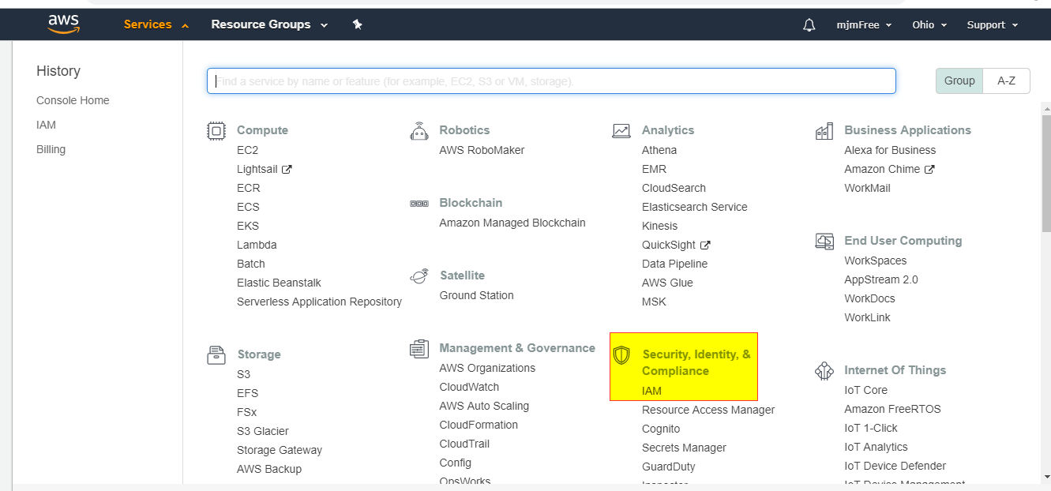

1. Best Security Practice
   1. Activate MFA on your account
   2. 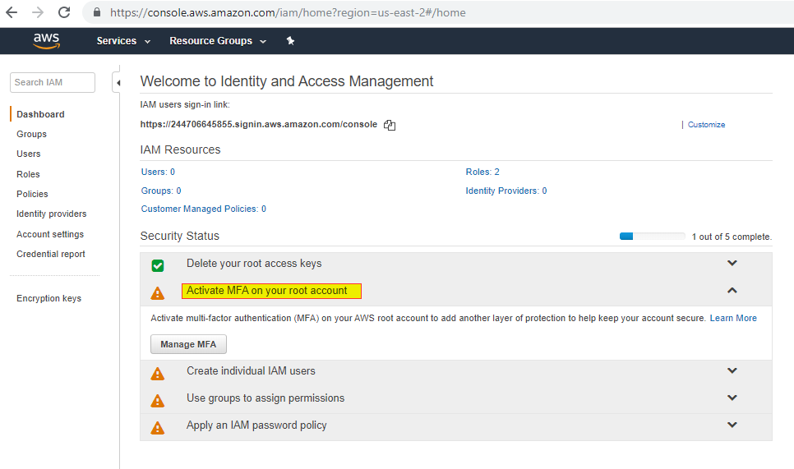
   3. 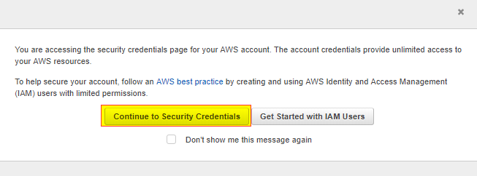
   4. 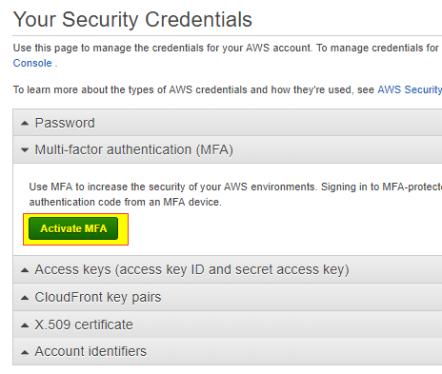
   5. 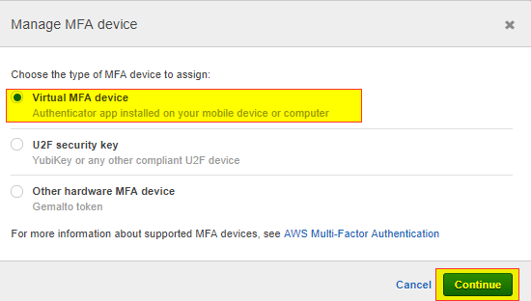
   6. 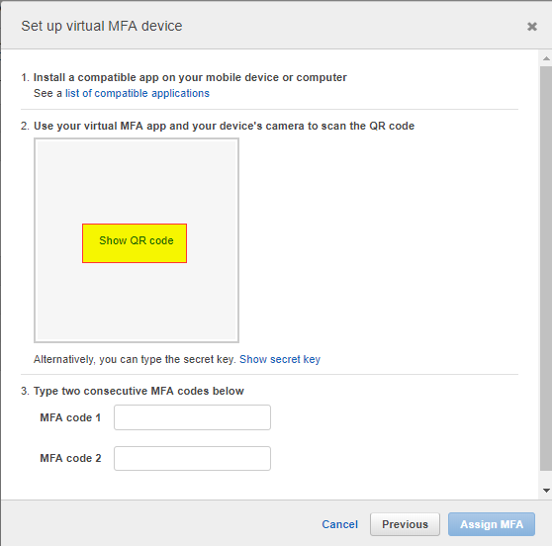
   7. 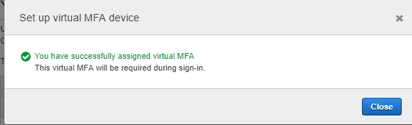
   8. Can us the Google Authenticator app
   9. Works on IOS and Android
   10. 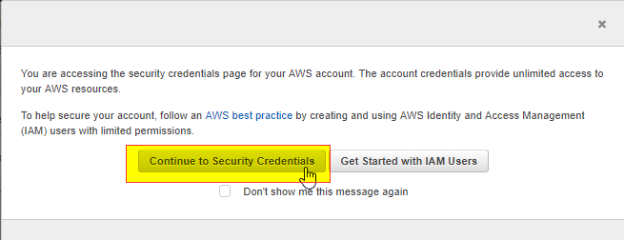
   11. 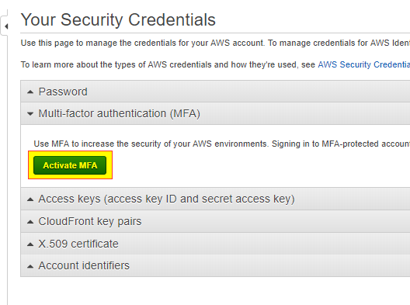
   12. 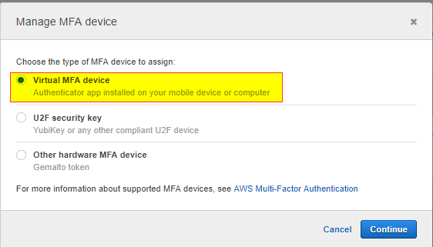
   13. 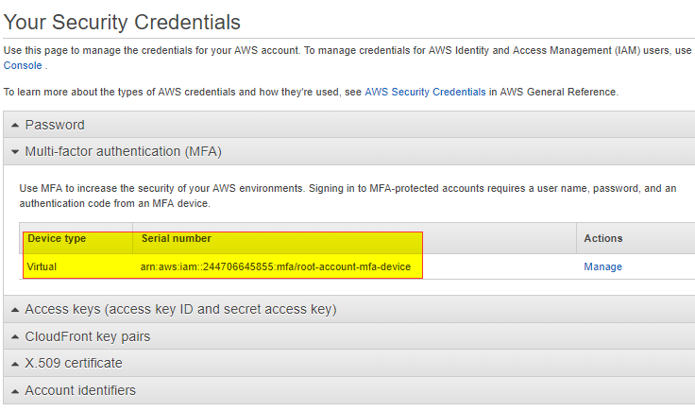
2. Create User
   1. 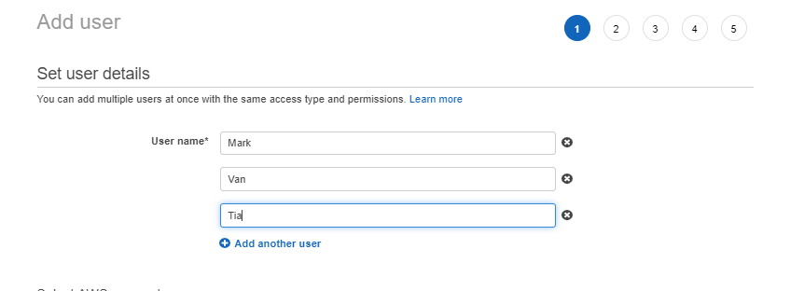
   2. 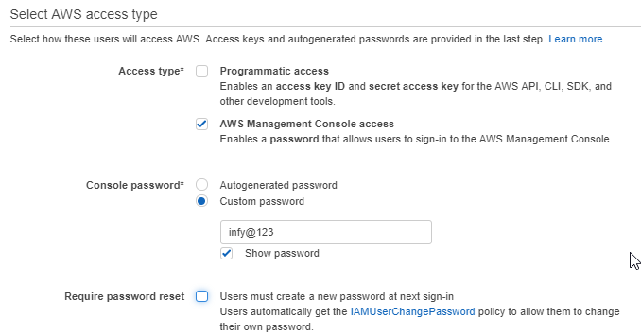
   3. 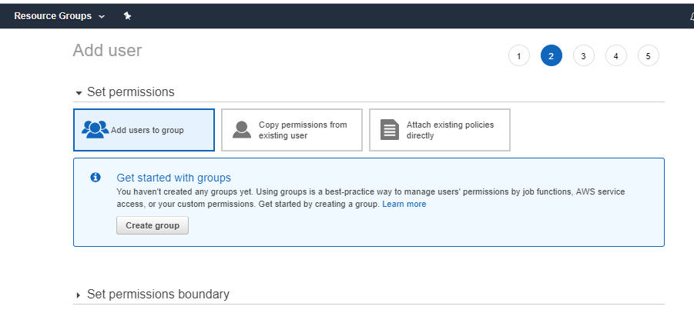
   4. 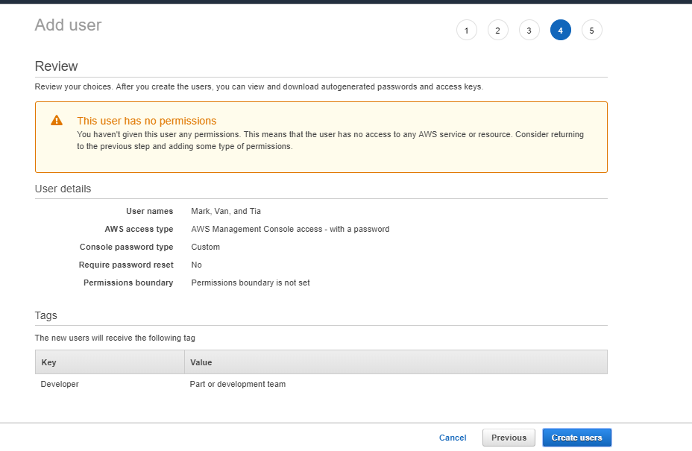
3. Regions, availability zones, data centers
   1. One region can have multiple Availability Zones and one AZ can have multiple data centers
      * 1. User created are Global across regions
4. Create Groups
   1. 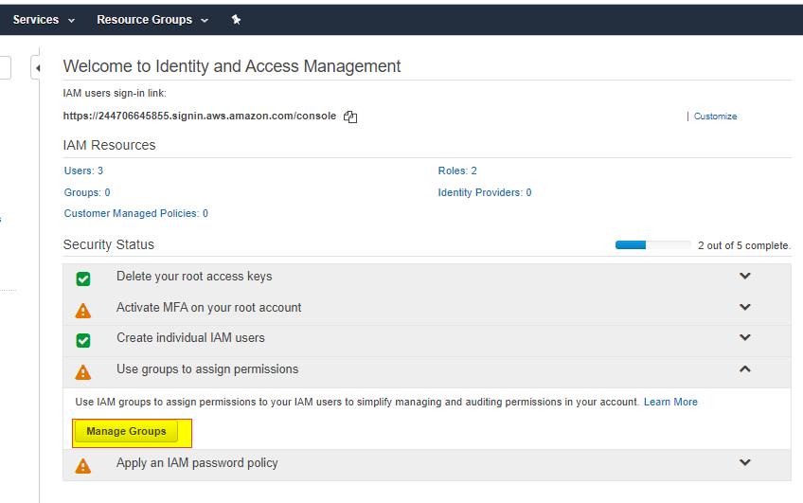
   2. 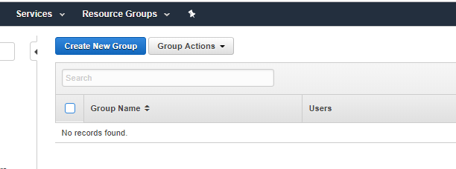
   3. 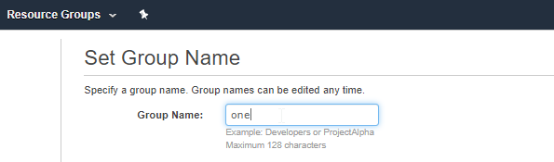
   4. 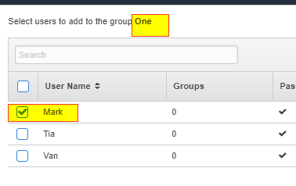
   5. 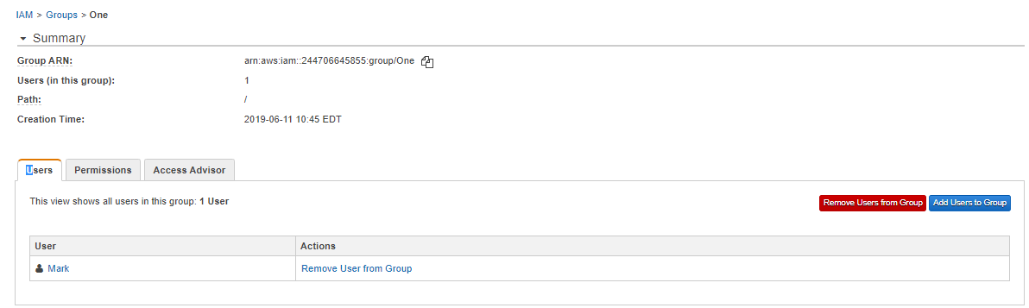

Day Two

1. Runtime policies
   1. One user or group can have different policies for different services
   2. One user can be part of 10 groups
   3. One AWS account can have a max of 100 groups
2. Hardware Infrustructure
   1. Disk – for local storage = EBS – Elastic Block Storage
   2. OS – Linux / WIN / MAC = AMI – Amazon Machine Images
   3. CPU cores = Instance Type
   4. RAM
   5. Network adapter – NACL = IP Address – public and private
   6. Firewall / Security = Security Groups
3. Build on premis infra infosys using he above h/w components
   1. Would take probably one month
4. Build one in the cloud
   1. Simple Monthly Calculation
      1. <https://calculator.s3.amazonaws.com/index.html>
   2. Price will vary based on the Region / Zone
      1. Tax, dollar rate exchange, AWS infra structure costs (Land, electric)
      2. 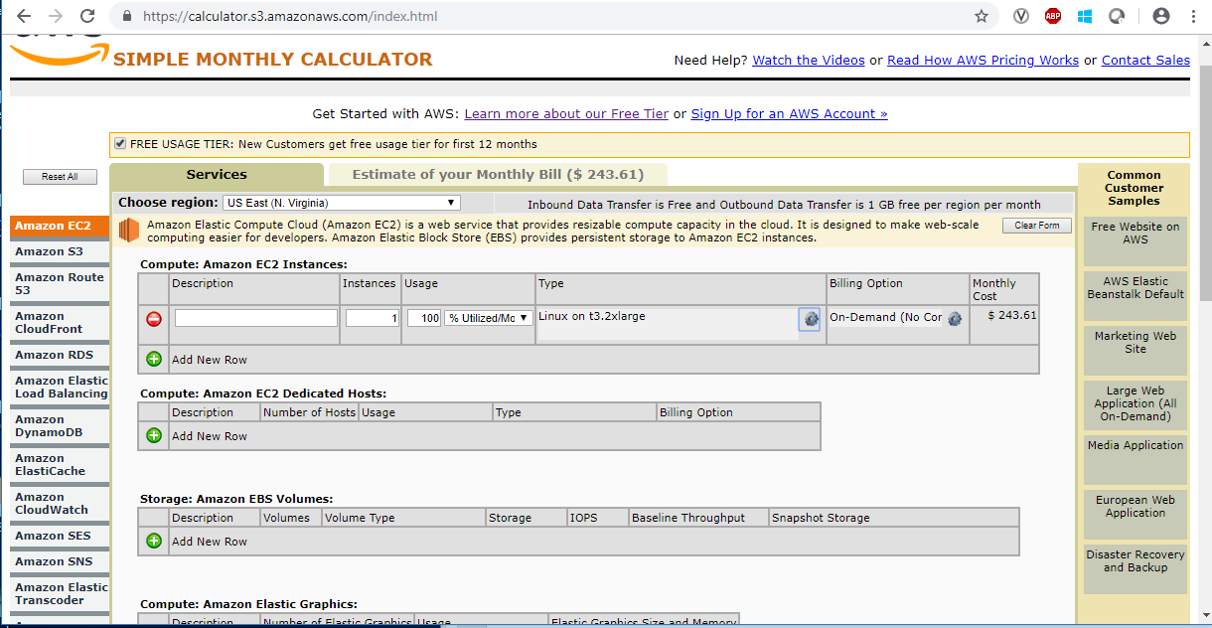
   3. aws total cost of ownership
      1. <https://aws.amazon.com/tco-calculator/>
         1. Click launch calculator button for the following
            1. <https://awstcocalculator.com/>
      2. 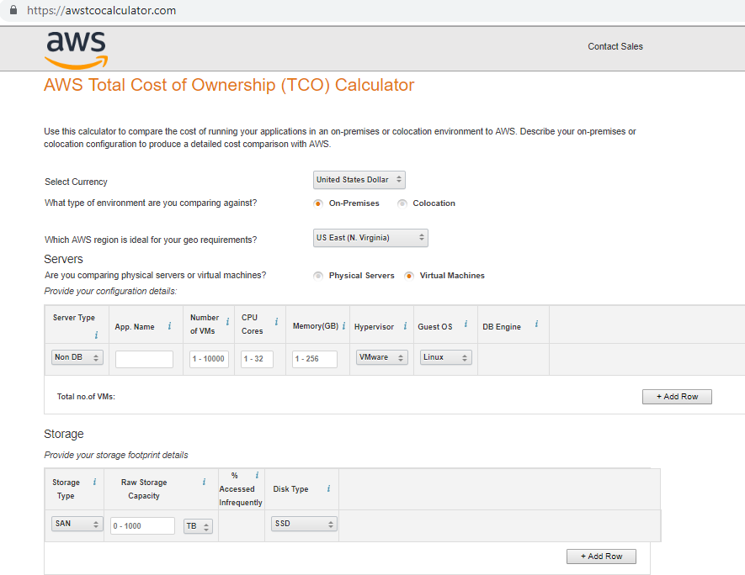
   4. Step 1: Choose an Amazon Machine Image (AMI)
   5. 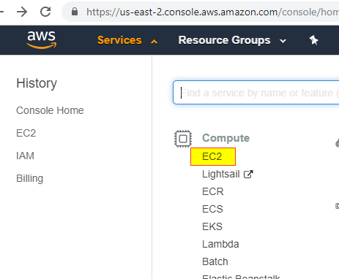
   6. 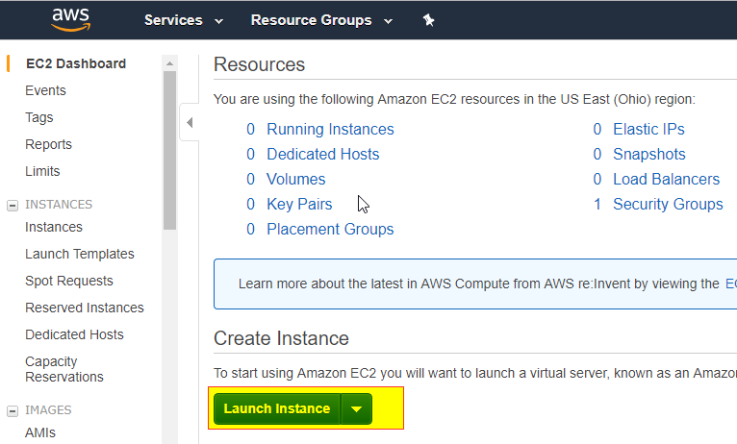
   7. 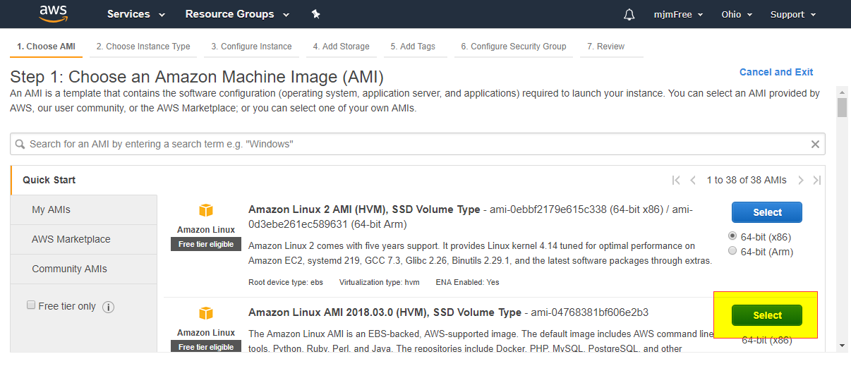
   8. Based on application
      1. Select general momory or computing optimized
      2. 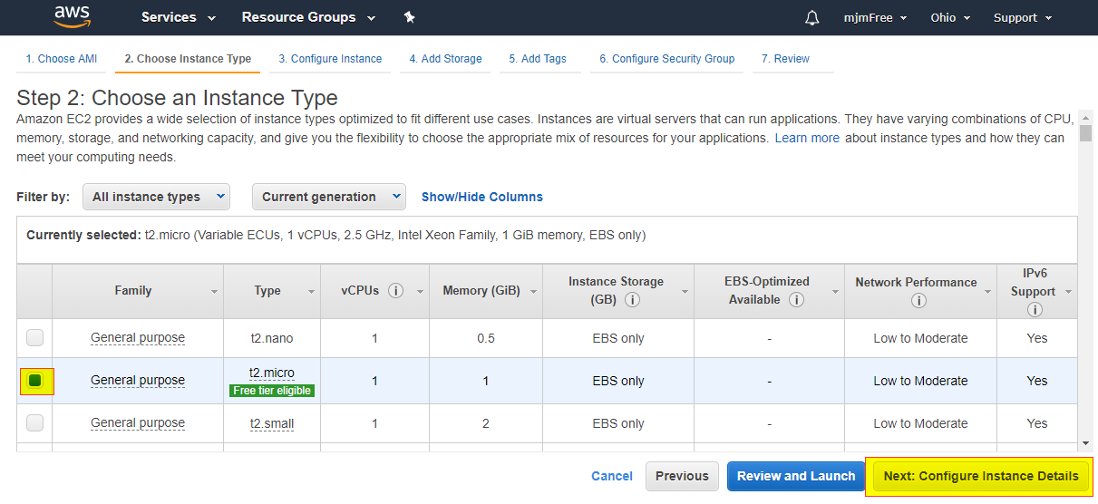
   9. When spot increased over bid price, the running instance will be terminated
   10. In the advanced details section (bottom section not shown on screen shot) can enter details for scripts
   11. 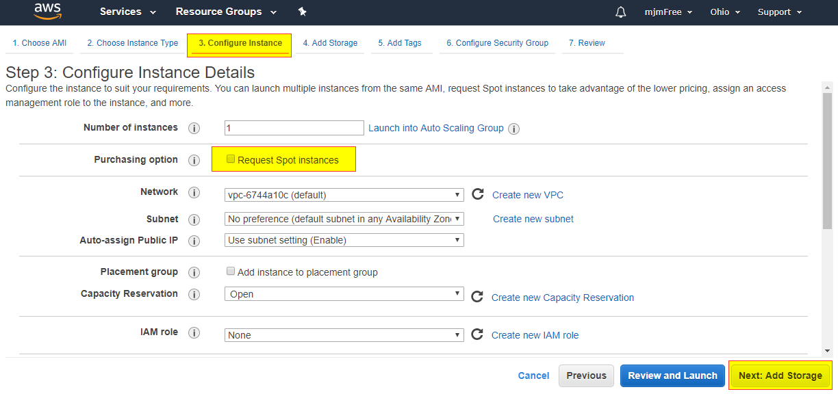
   12. 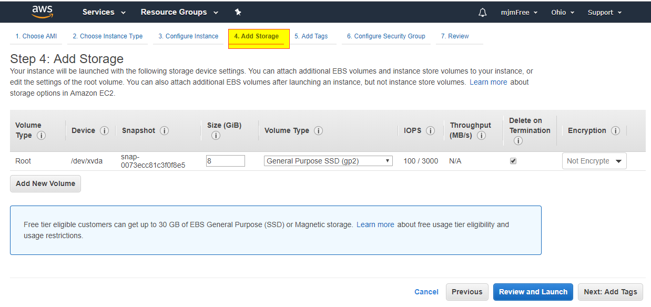
   13. 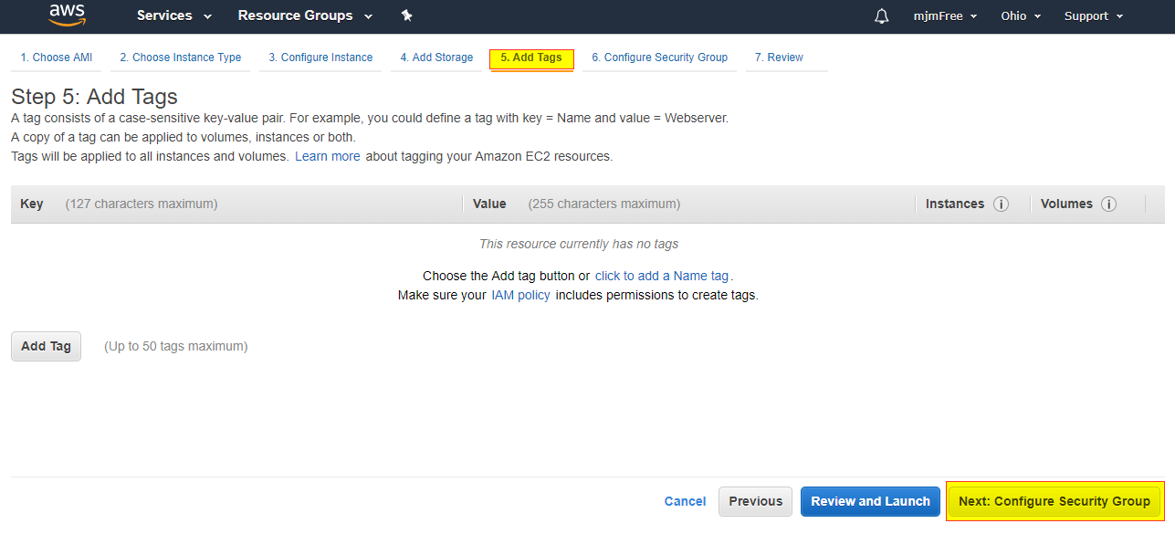
   14. 
   15. 
   16. 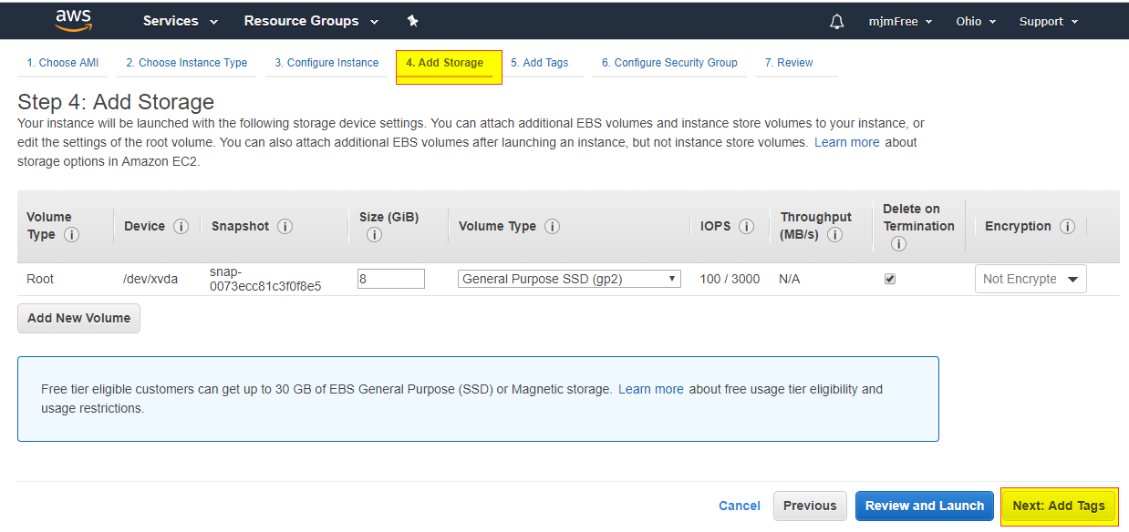
   17. 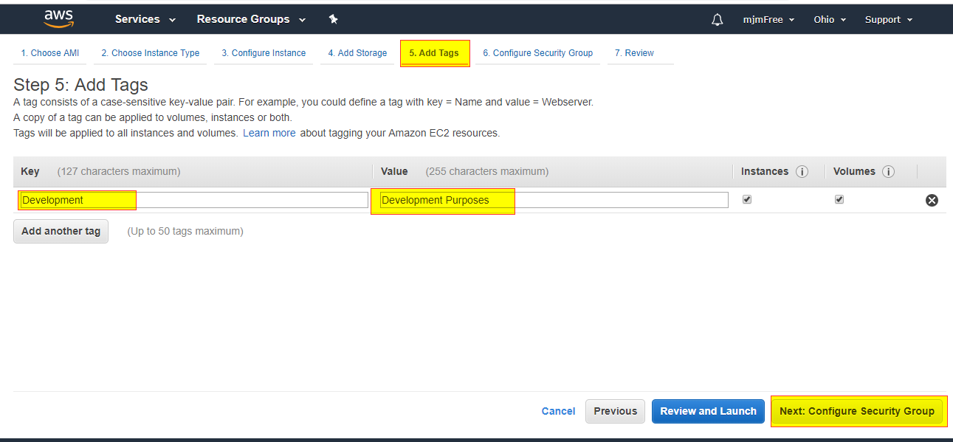
   18. 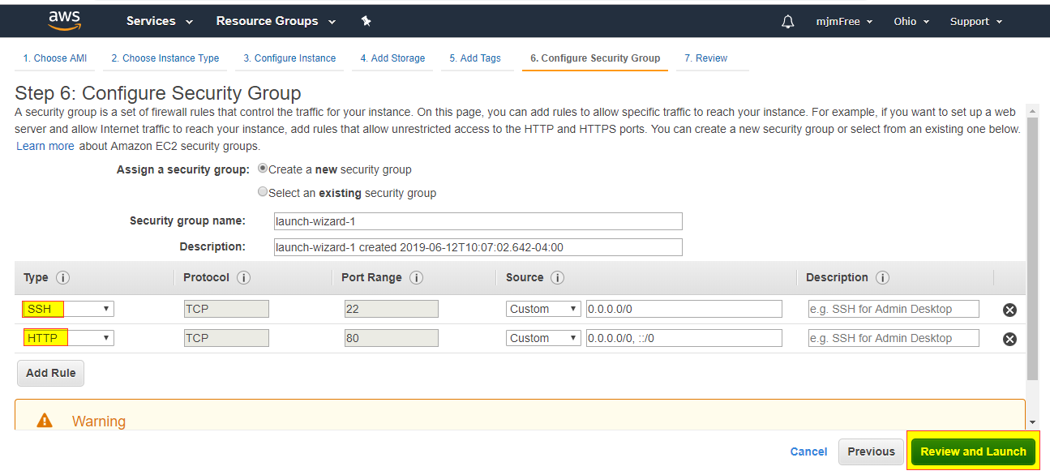
   19. 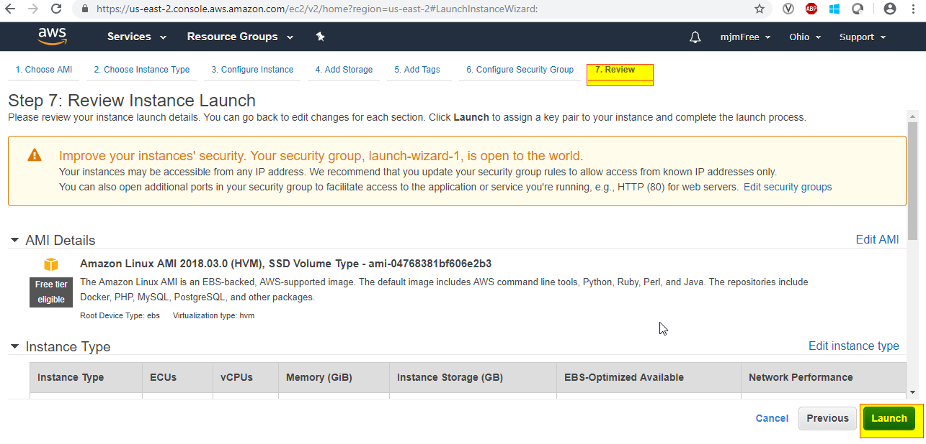
   20. 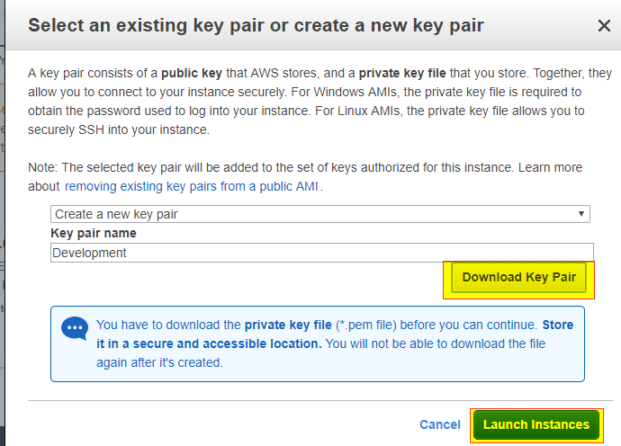
   21. 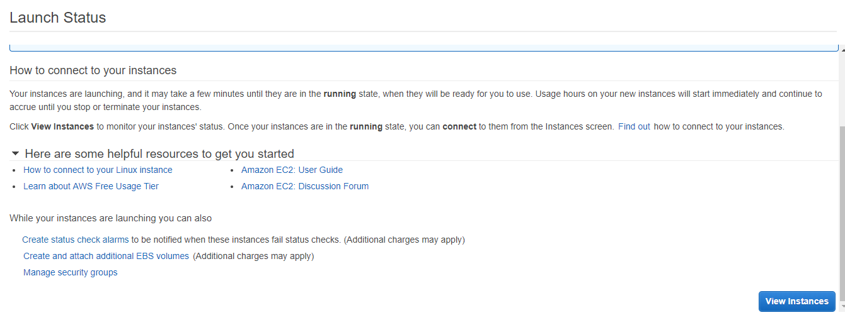
   22. 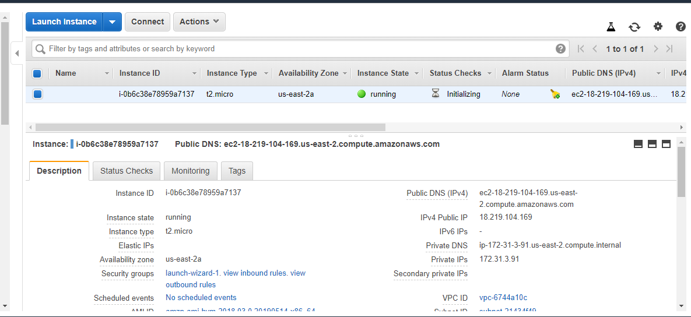
5. Availability zones are connected
   1. Using a private ip address the outside world only one ec2 instance can be used
      1. That is why need to also have a public IP address
   2. If connection error in the Infy Network
      1. Use the cloud connect
6. Start the http services
   1. 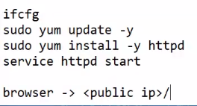
7. To connect
   1. Linux use putty
   2. Windows use RDP
8. S3 – simple storage services
   1. Like an external disk
   2. S3 Bucket -> S3 Folder -> S3 Object
   3. For S3 Bucket need to select a region
      1. Permissions are at the object level
         1. Up to 5 GB included with free setup

Day 3

1. Security group is present at what level
   1. At the instance level
   2. 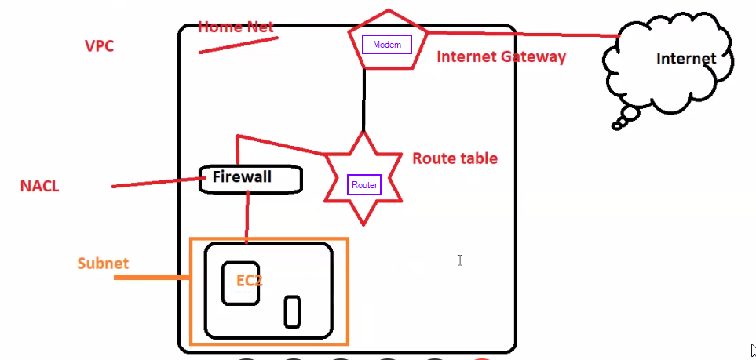
2. What are the default components created
   1. Firewall
   2. Ipc address
   3. Enabling ports
   4. VPC
3. Network Access Control List
   1. Stateless
   2. 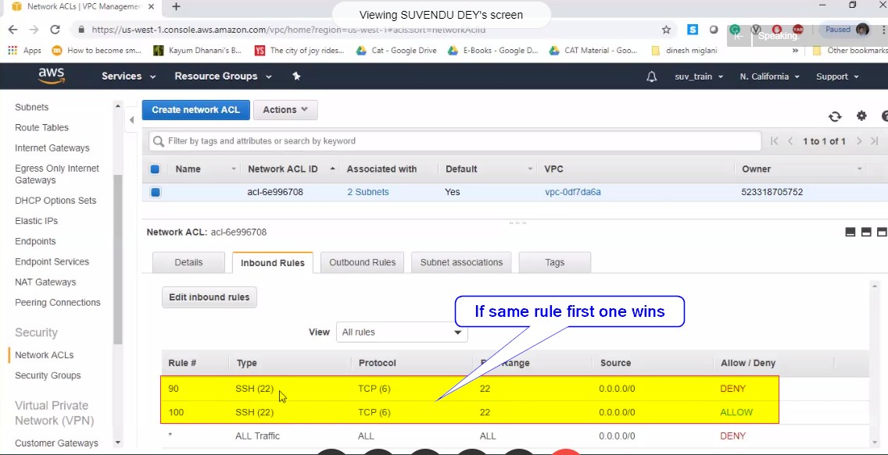
   3. 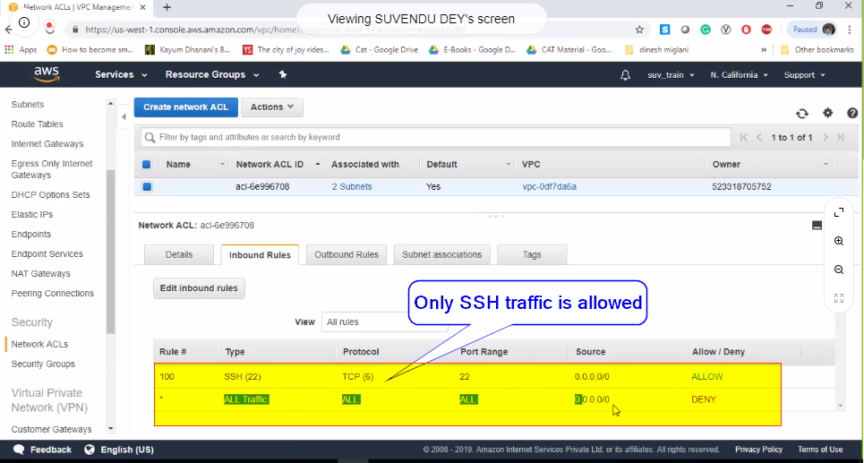
4. Monotoring and Metrics

* 1. 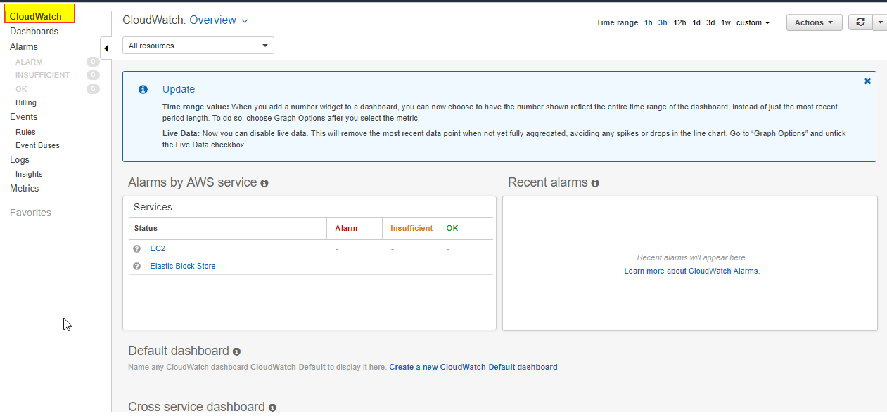

1. Elastic Load Balancer
   1. 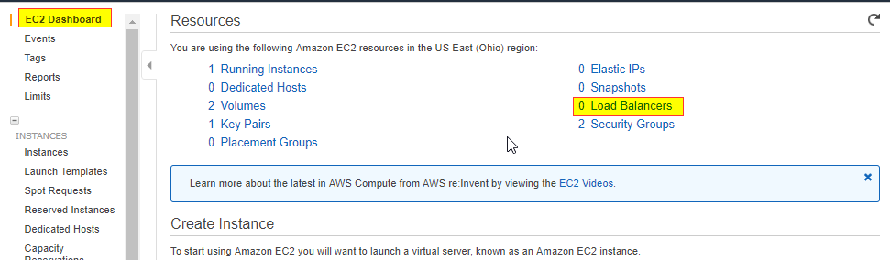
   2. 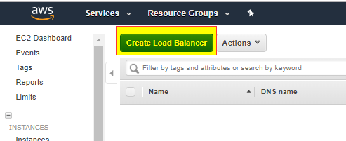
   3. 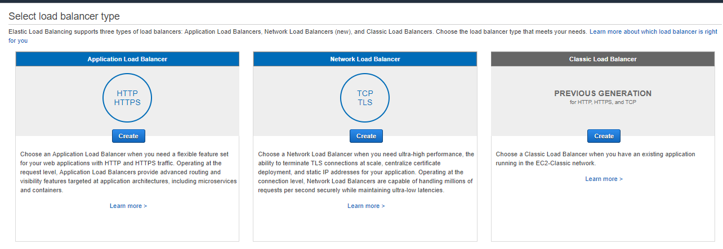
2. Training
   1. AWS 10 minute tutioral

# AWS Compute, Network and Storage Services

Day 1

1. Name the deployment models in Cloud Computing
   1. Private
   2. Public
   3. Hybrid
   4. Community
2. Cloud Service Models
3. 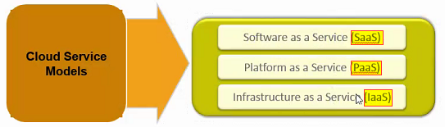
4. Questions
   1. What is a region?
      1. A region is a geographical area
   2. Whate is an Availability Zone?
      1. One region can have multiple AZ’s
   3. Why multiple AZ in one region?
      1. For fault tollarance
5. EC2 - Elastic Computer Cloud
6. AMI - Amazon Machine Image
7. 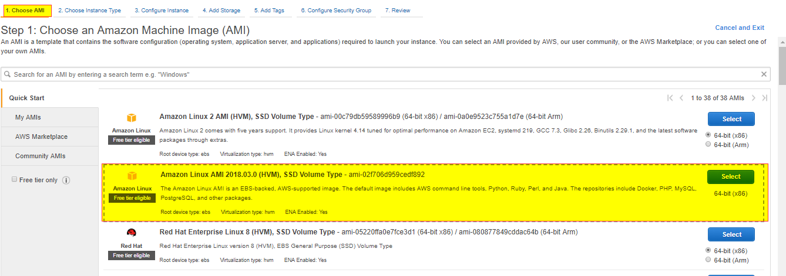
8. 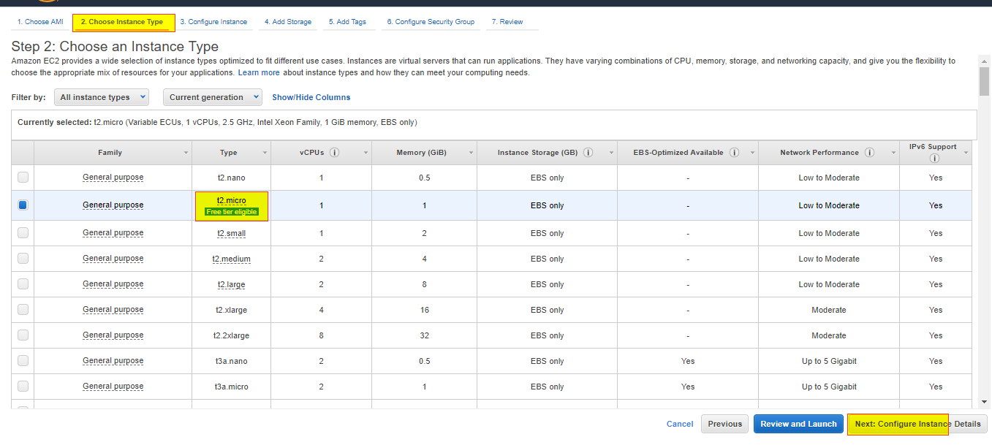
9. 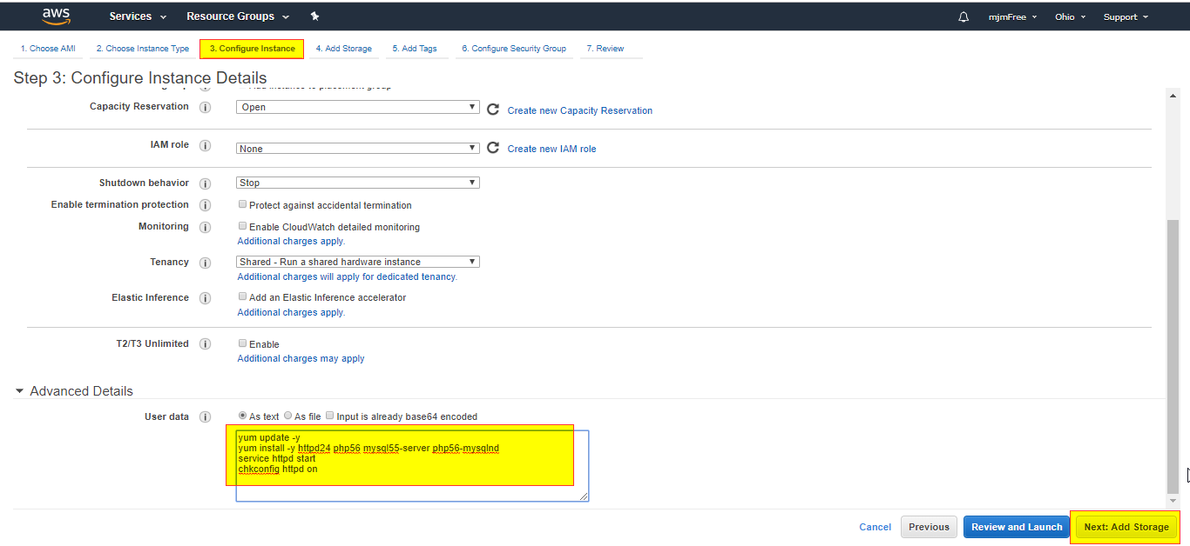

yum update -yyum install -y httpd24 php56 mysql55-server php56-mysqlndservice httpd startchkconfig httpd on

1. 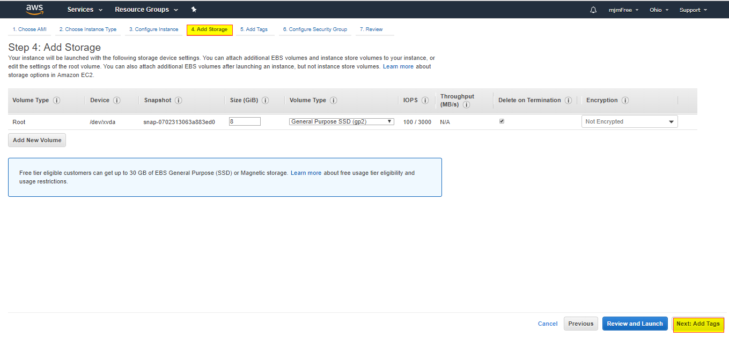
2. 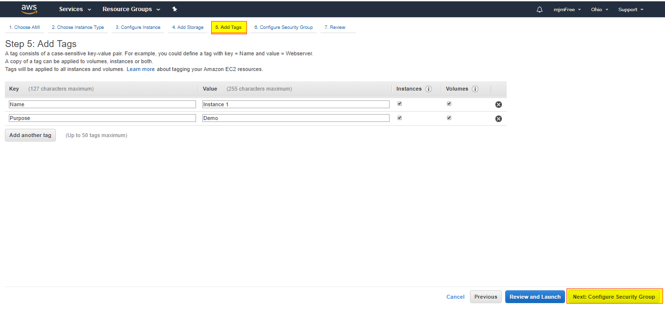
3. 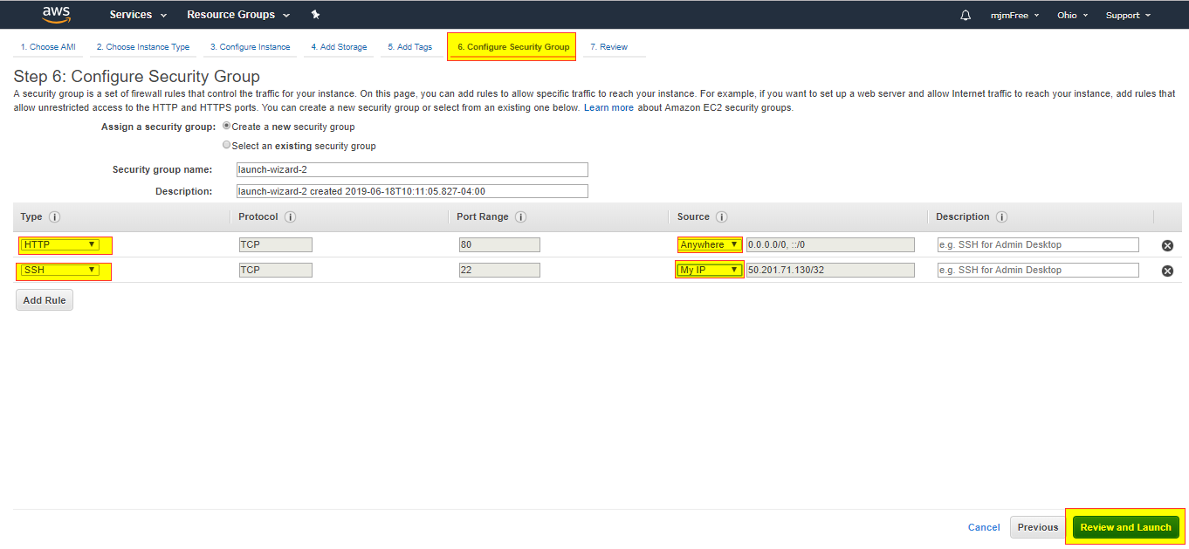
4. 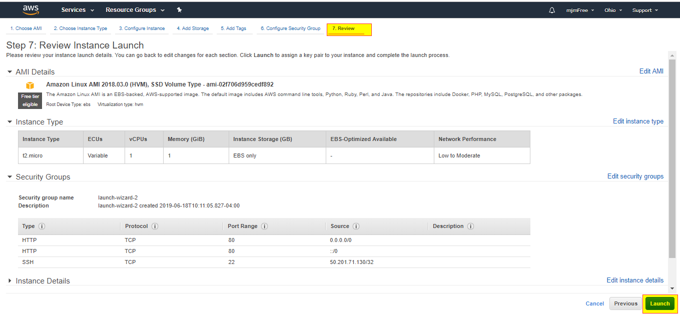
5. 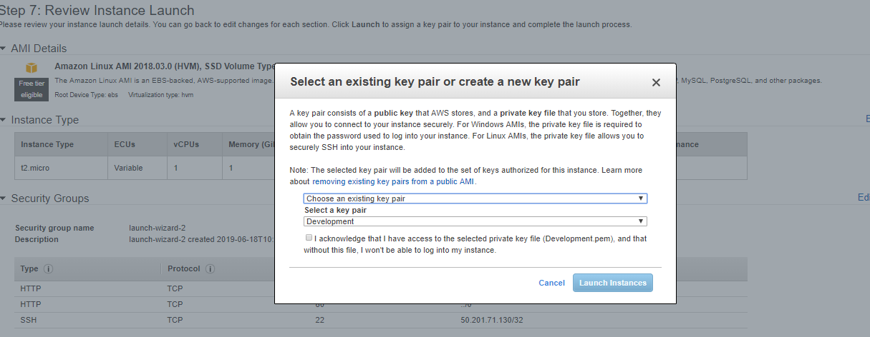
6. 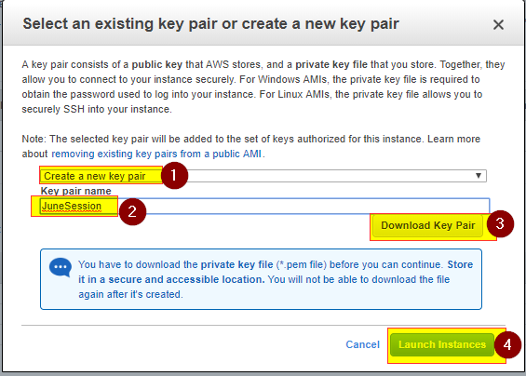
7. Pubic key
   1. It is file that is saved on the AWS Cloud
8. Private Key
   1. Its is a .pem file that is saved on the users’s machine.
   2. Need to use this for secure connection
9. 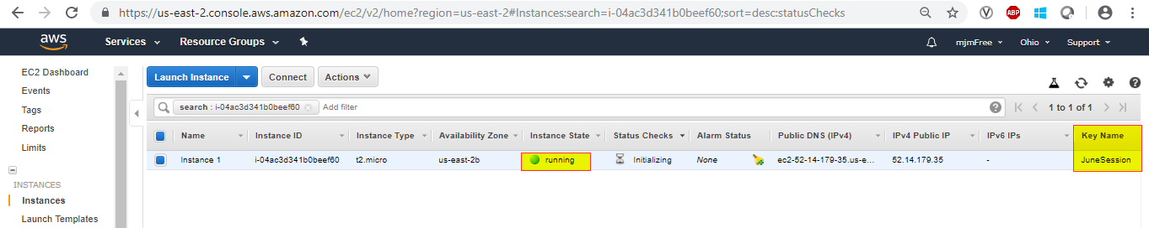
10. To connect from the Infy network need to use cloud connect
    1. <https://cloudconnect/>
11. Default User name is ec2-user
12. 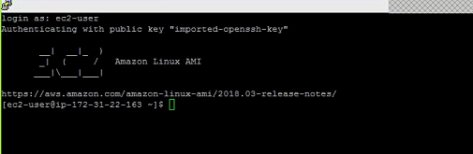

Day 2

1. AWS Compute, Network and Storage Services
2. When you stop and restart an EC2 instance
   1. The IP will Change
3. Elastic IP - - It is a a static public IP.
   1. This is only free for one hour
   2. .,p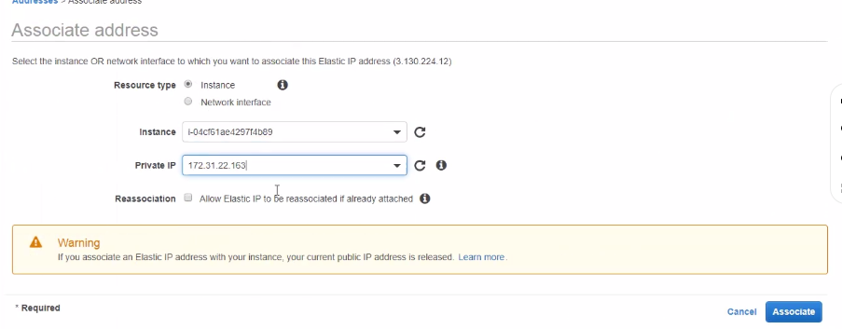
4. Key Pair
   1. 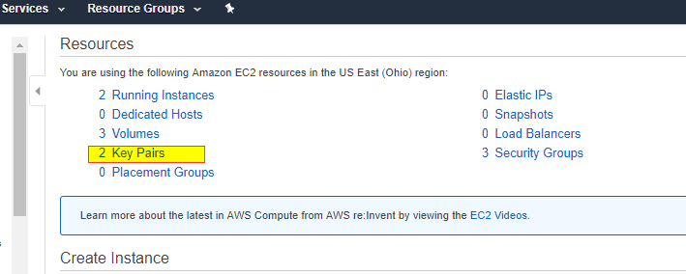
   2. 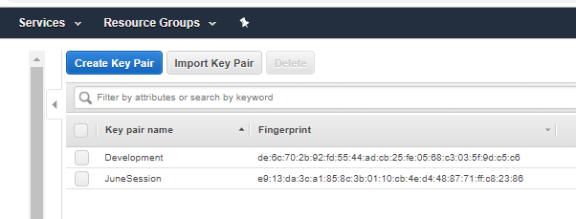
5. ELB – Elastic Load Balancer
   1. Distributes the incomming traffice among set of healthy EC2 Instances
   2. ELB profixes a single endpoint
   3. Performs health checks on EC2 instances
6. Three type of ELB’s
   1. Clasic LB 🡪 It is used to distribute the traffice among EC2 instances on which same app is running
   2. Application LB 🡪 Path base routing
      1. Ex: [www.abc/indea](http://www.abc/indea) --> instance -1
      2. Ex: [www.abc/usa](http://www.abc/usa) --> Instance 2
      3. Uses layer 7 of osi (HTTP)
   3. Network LB
      1. Orks on Layer 4 of OSI model (TCP)
7. Is ELB a Regionl Service?
   1. Yes, will distribute to different AZ (availability zones) based on the same region
8. Clasic LB Demo
   1. 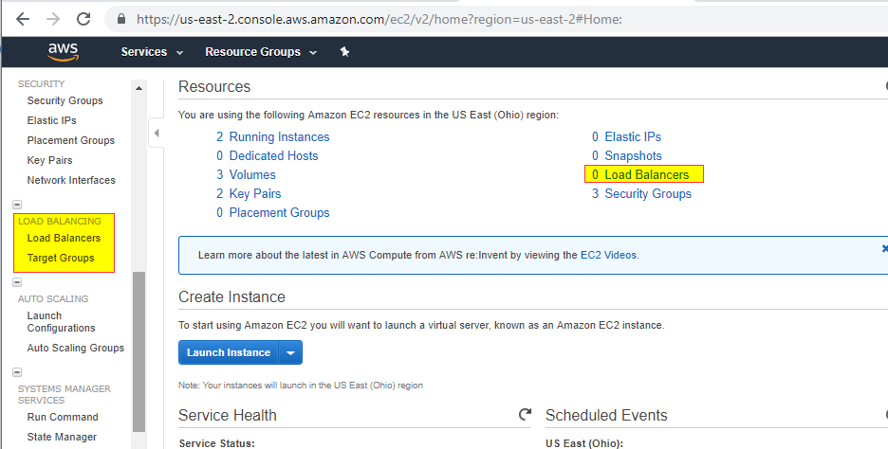
   2. 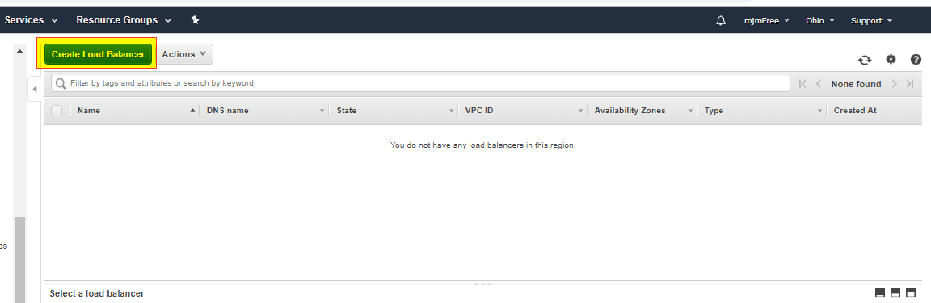
   3. 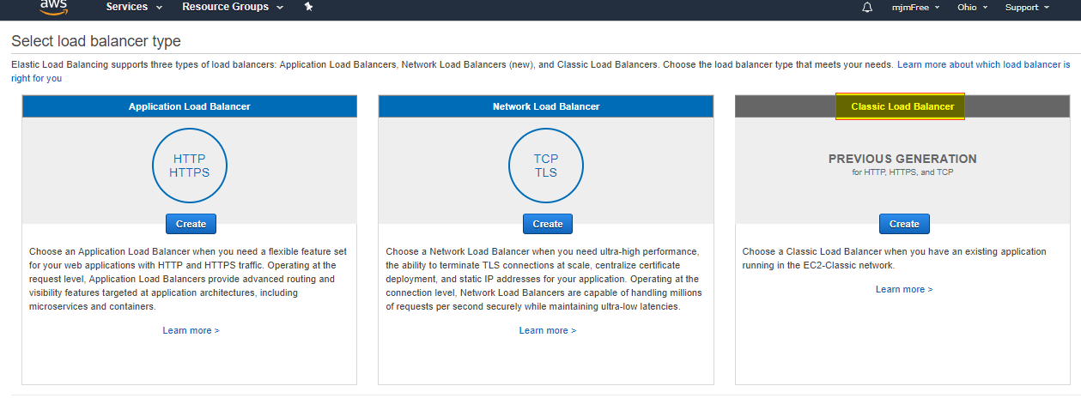
   4. 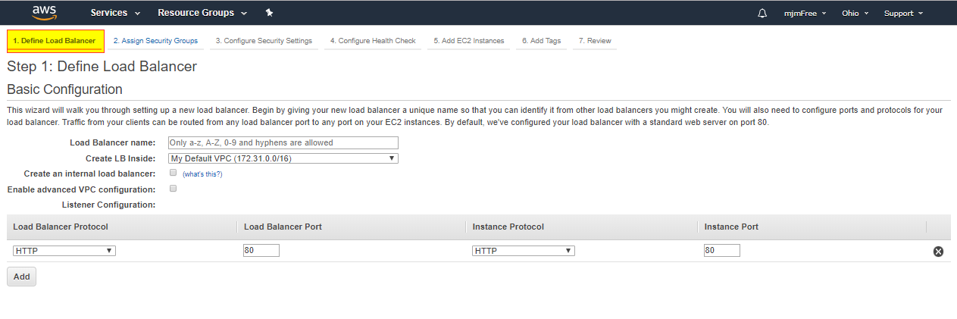
   5. 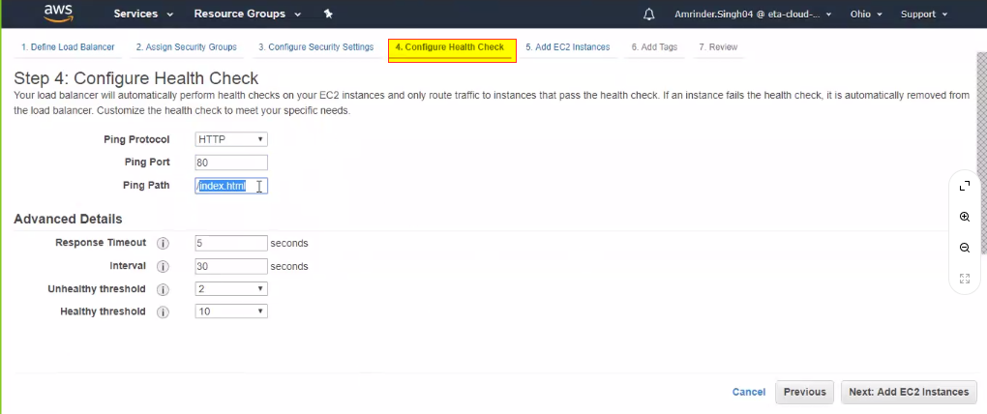
   6. 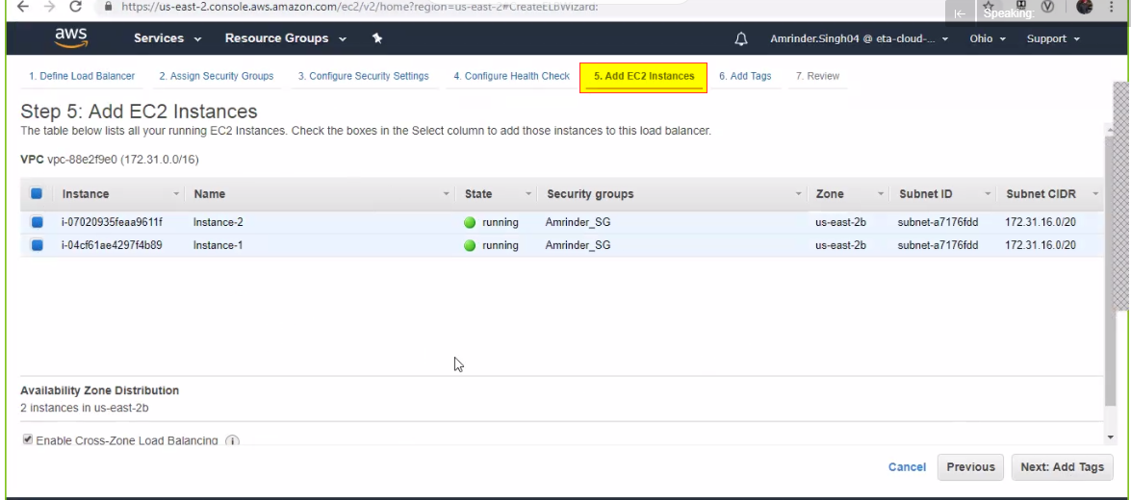
   7. 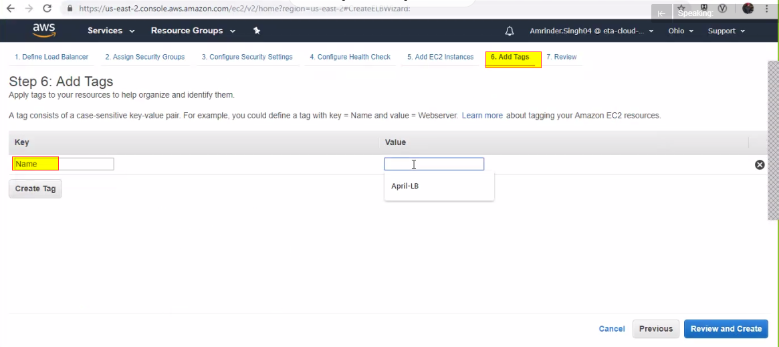
   8. 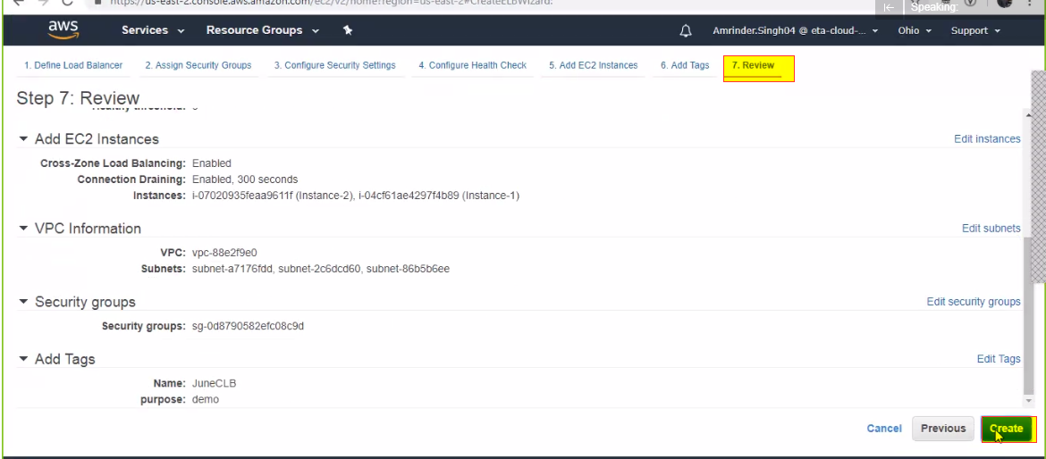
   9. 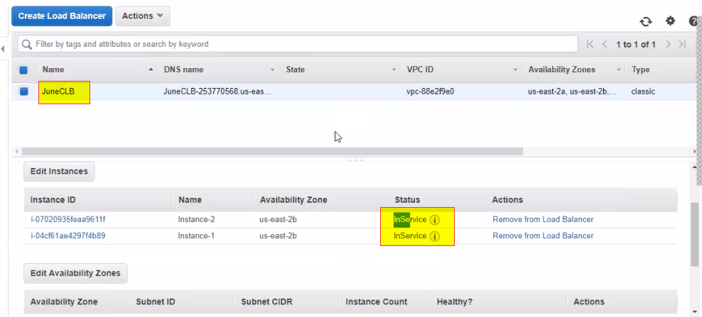
9. Application Load balancer (Path based routing)
   1. First need to create a target Group
      1. A group of simular EC2 instances
      2. 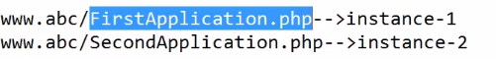
   2. 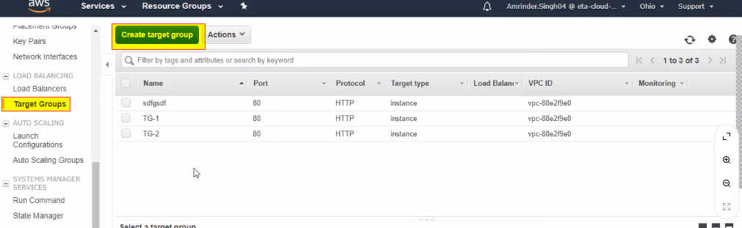
   3. 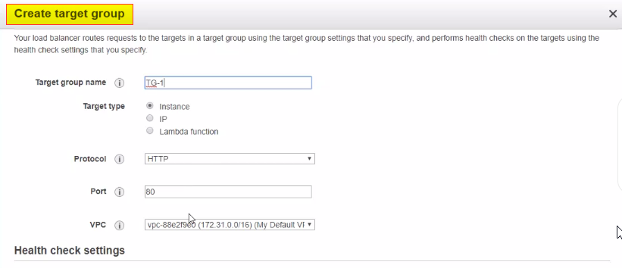
   4. 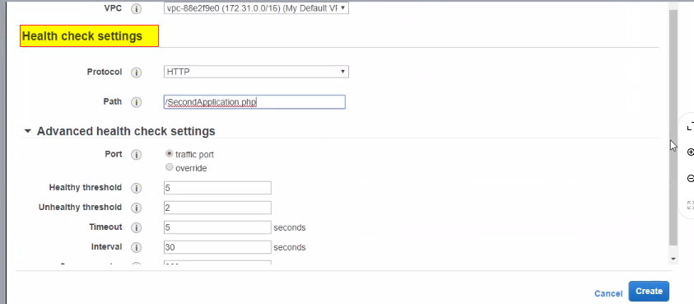
   5. 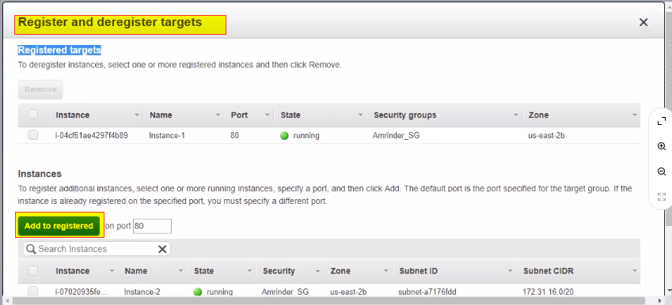
   6. 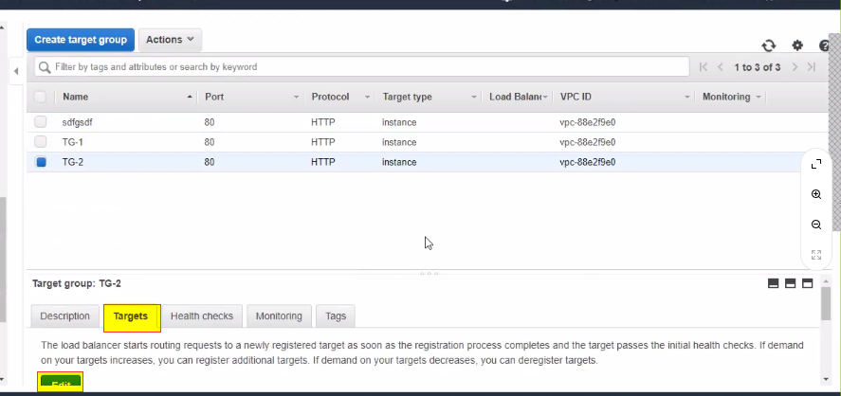
   7. Next create the Load balancers
   8. 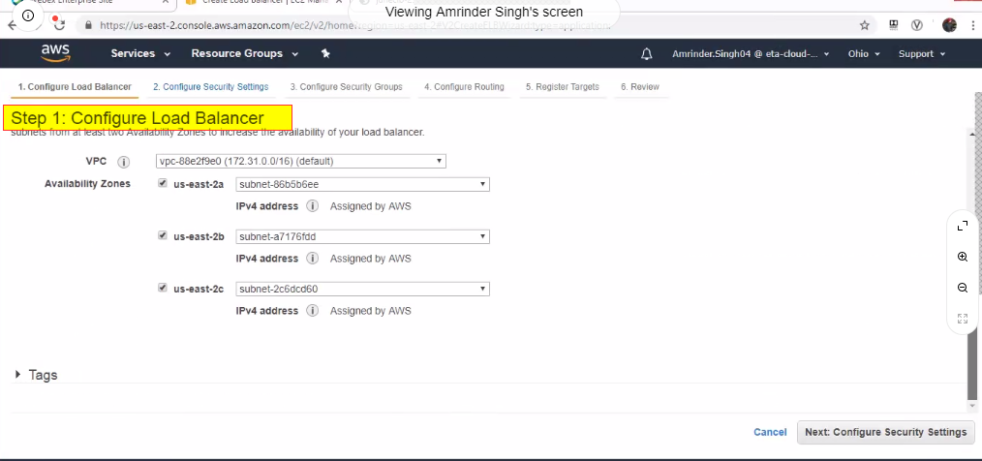
   9. 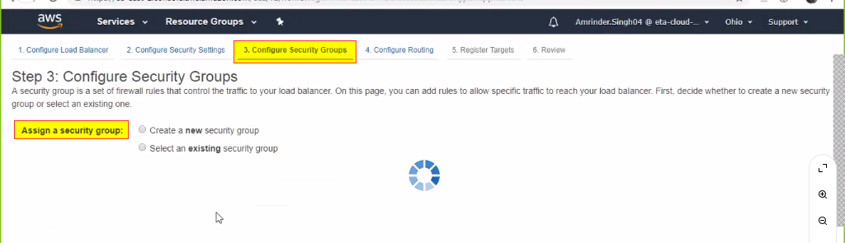
   10. 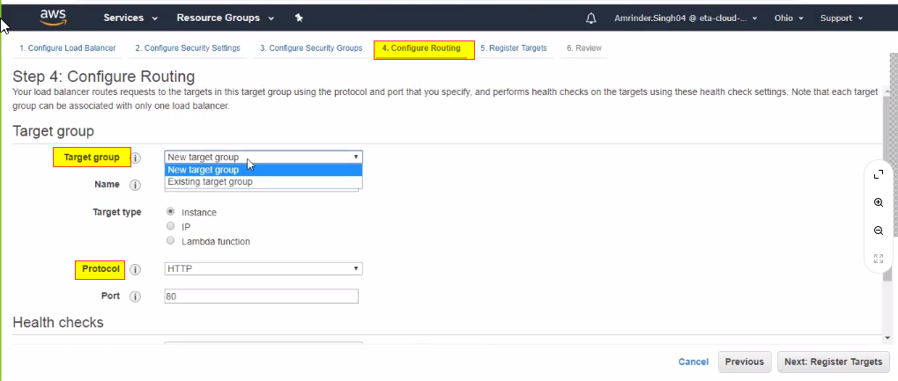
   11. 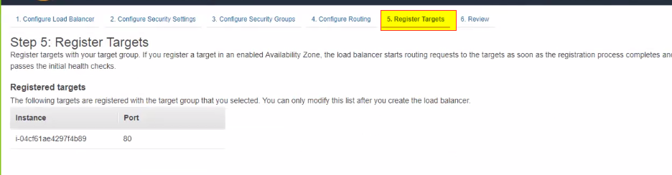
   12. 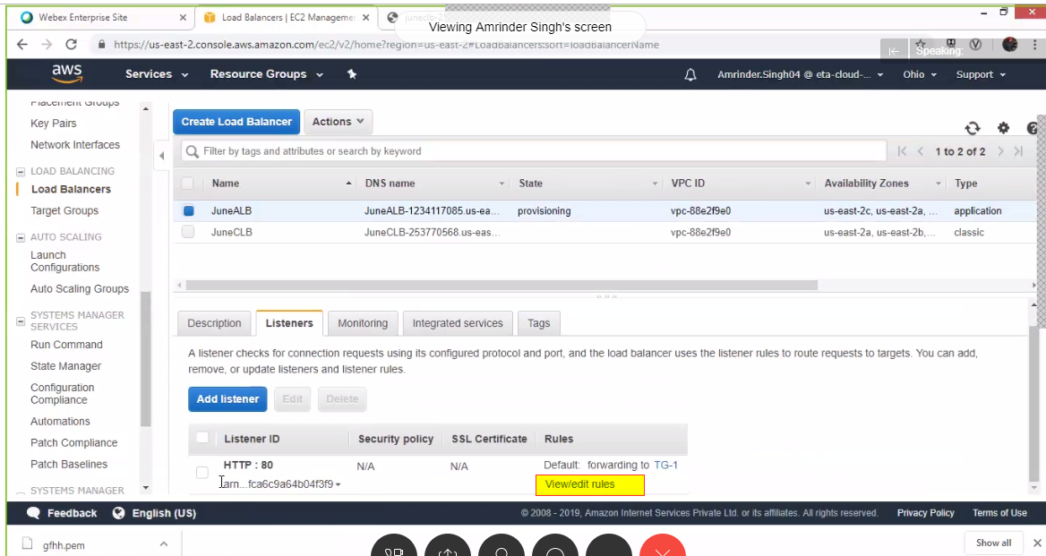
   13. 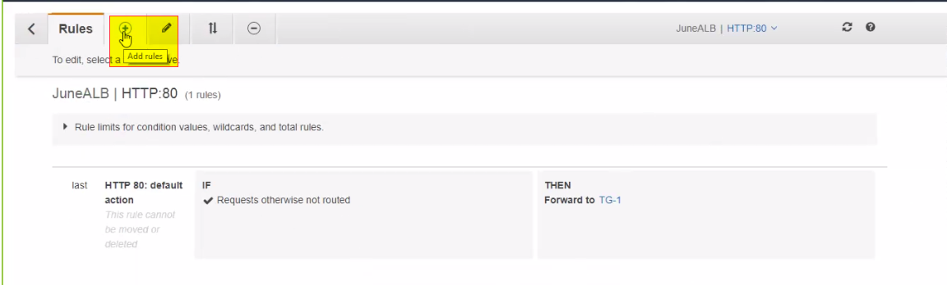
   14. 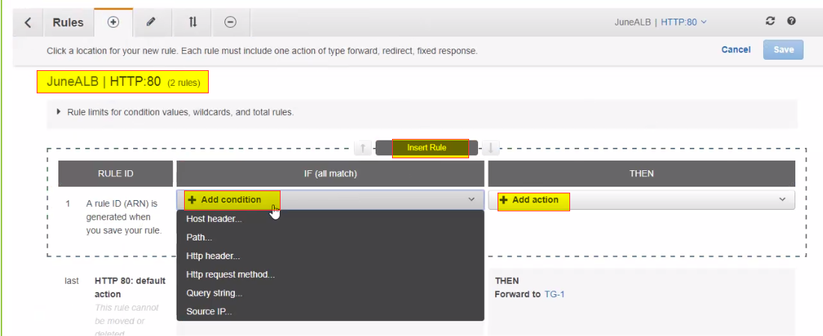
   15. 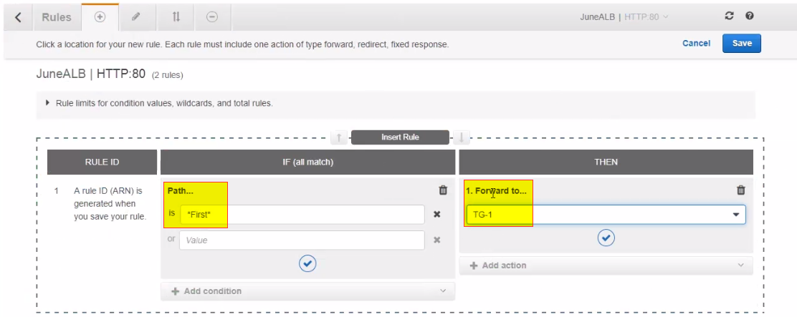
   16. 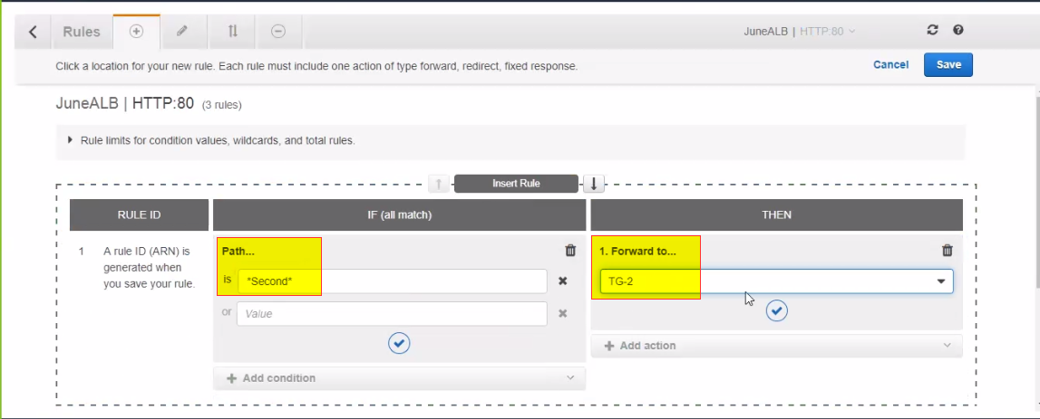
   17. 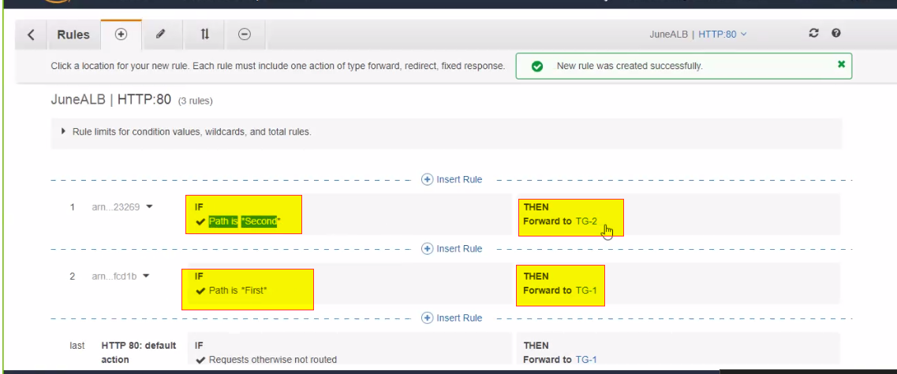
10. Auto scaling
    1. Addition and deletion of resources based on demand
       1. AWS uses horizontal scaling, additional instances
11. Two Auto Scaling Components
    1. Launch Configuration
       1. A template that wil be used to automatically launch EC2 instances
    2. Autoscaling Group
       1. Used to specify the policy when the scaling should happen

Day 3

1. Auto Scaling configuration
   1. 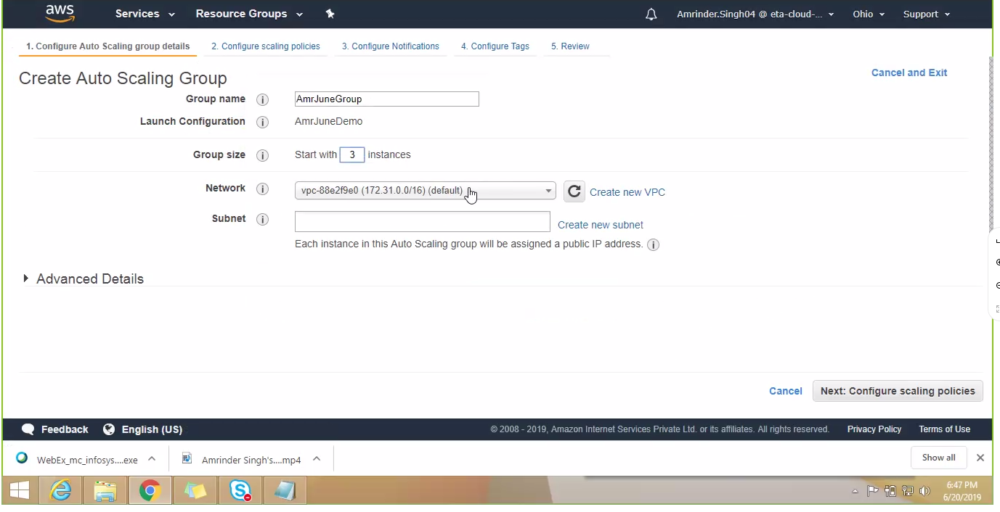
   2. 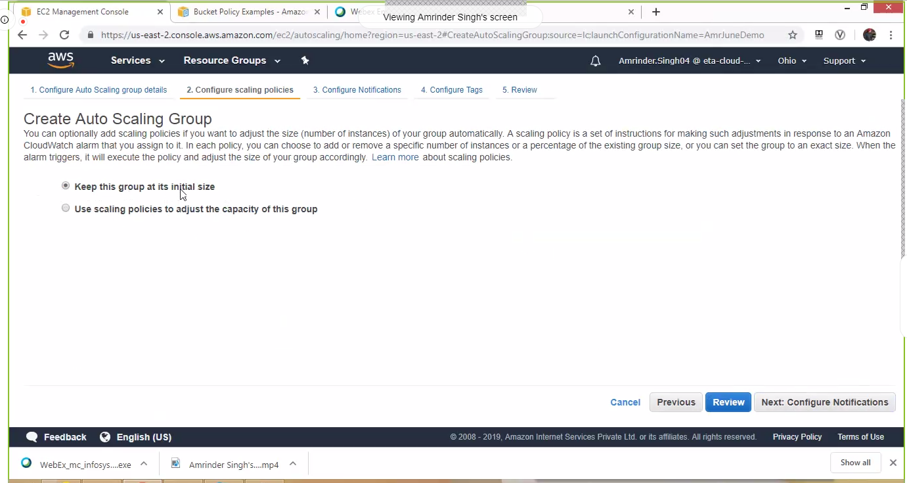
   3. If click second option, ‘use scaling policies..’ get the following
   4. 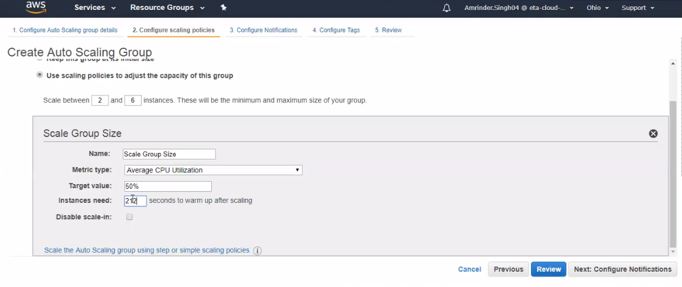
   5. 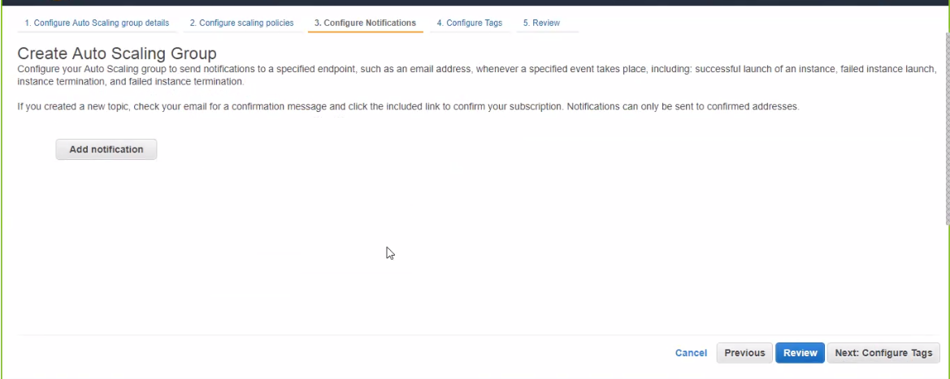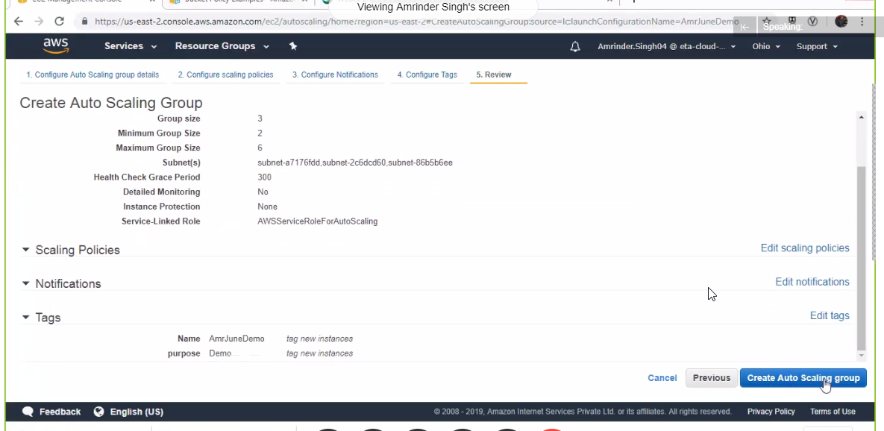
   6. 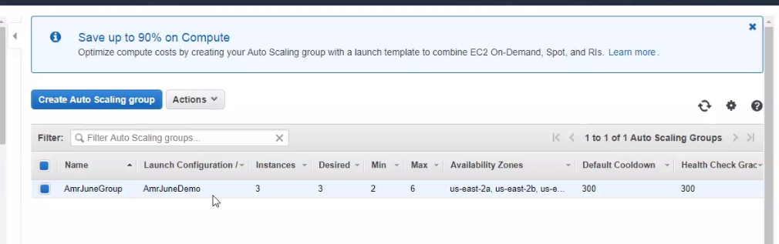
   7. If stop or terminate the instance it will automatically scale per the policy setting
2. Elastic Beanstalk
   1. It is a PaaS
   2. Find in Services
   3. 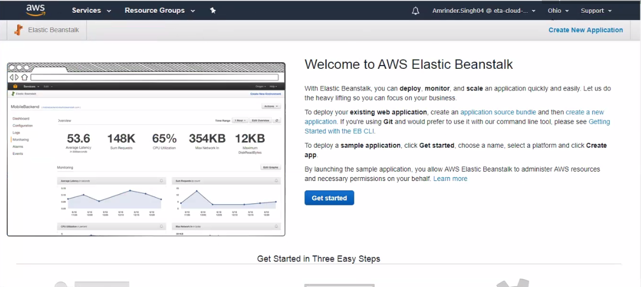
   4. 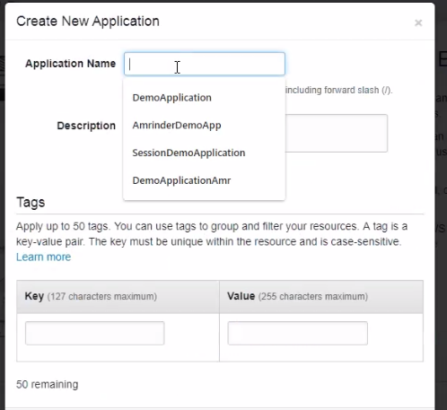
   5. 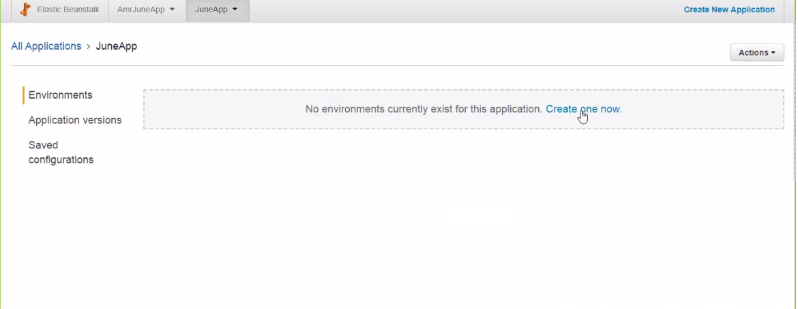
   6. 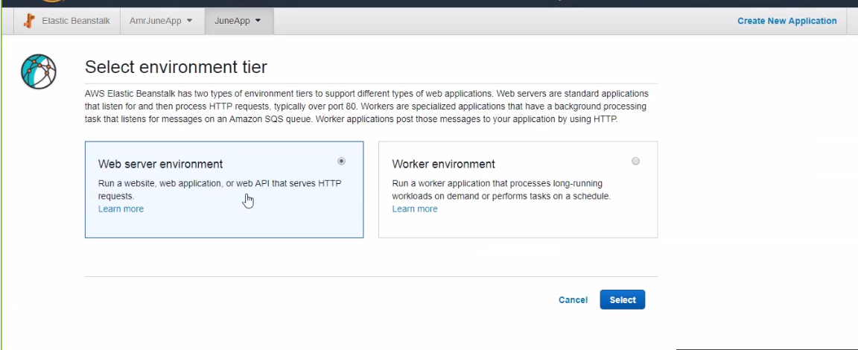
   7. 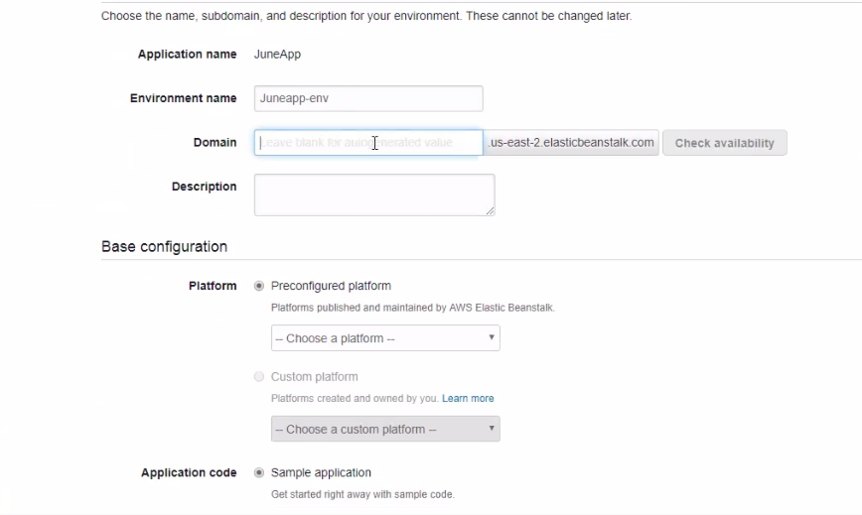
   8. Will see the EC2 instance that was created
   9. 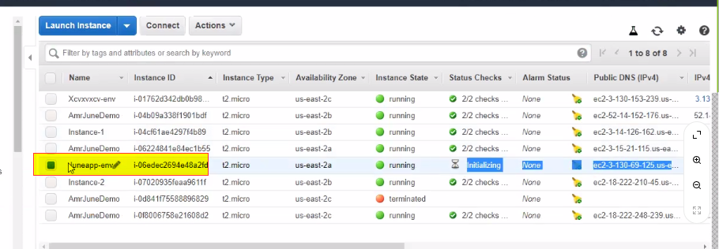
3. AWS Lambda
   1. It is serverless code running
   2. Need to create an IAM role
   3. 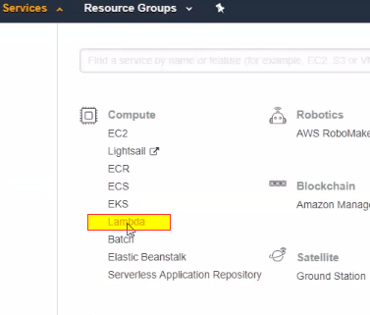
   4. 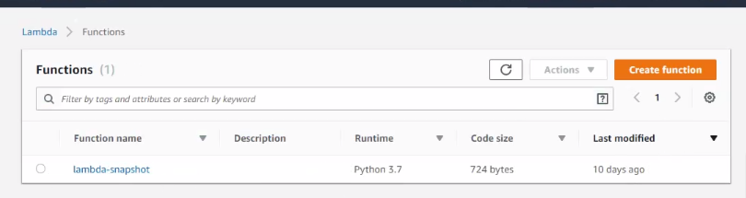
   5. 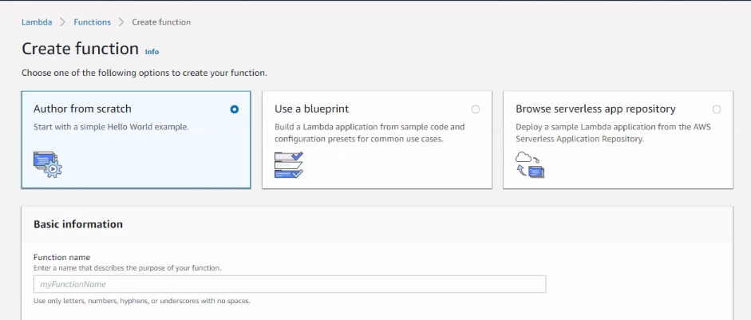
   6. 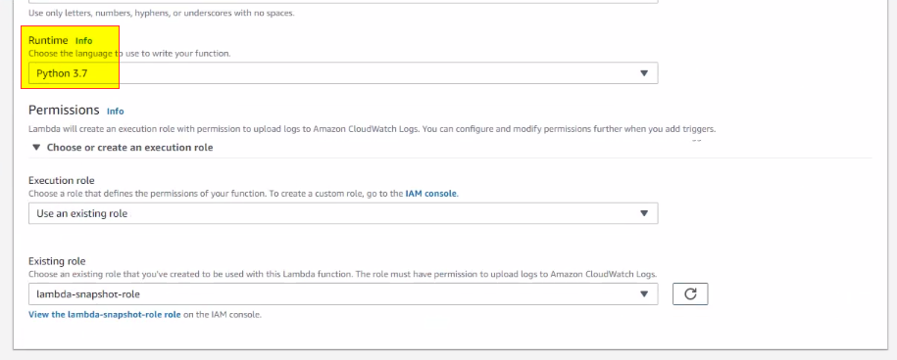
   7. 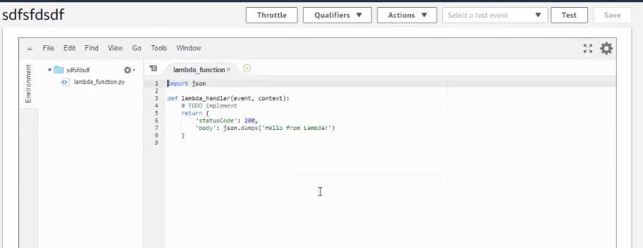
4. 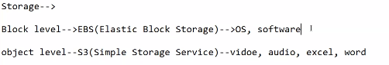
5. Bucket is a root folder where can upload objects
   1. <https://docs.aws.amazon.com/AmazonS3/latest/dev/example-bucket-policies.html>
   2. S3 Glacier is far less cost
      1. Uses the concept of a vault
   3. 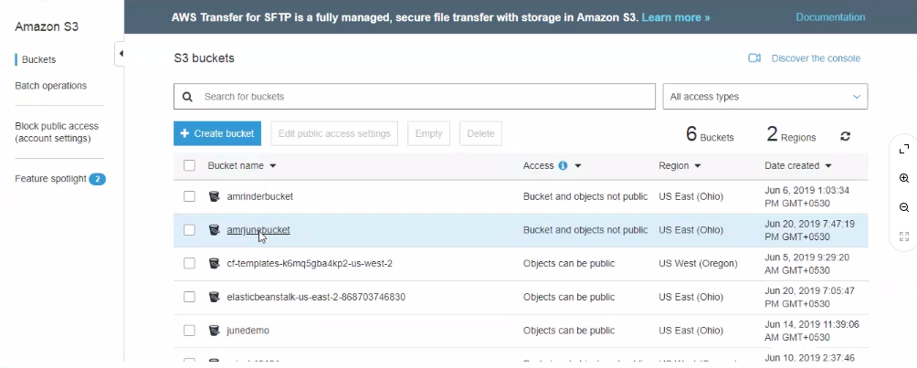
   4. 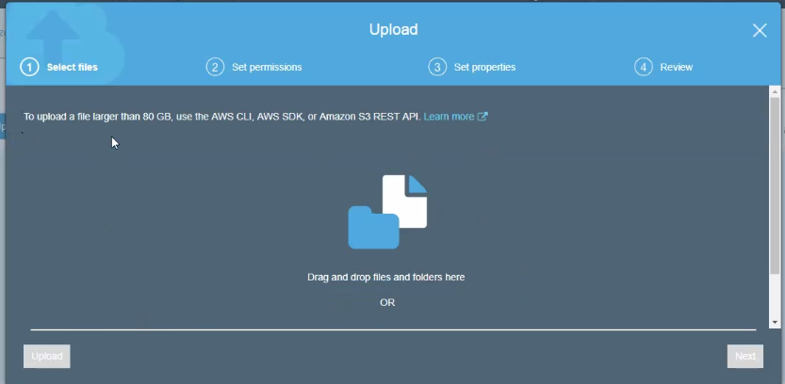
   5. 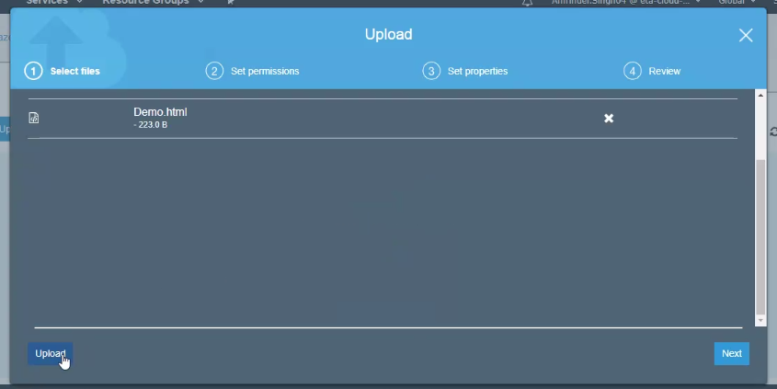
   6. 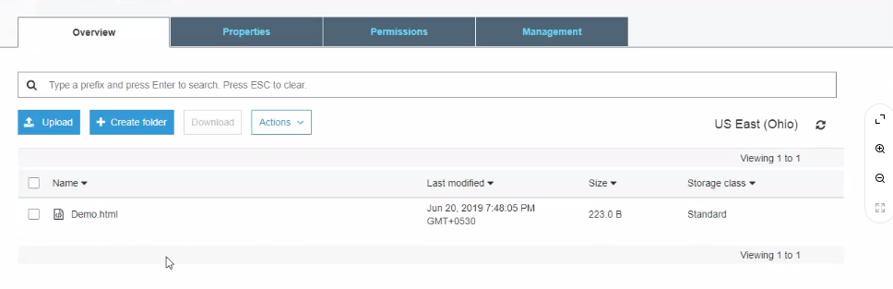
   7. 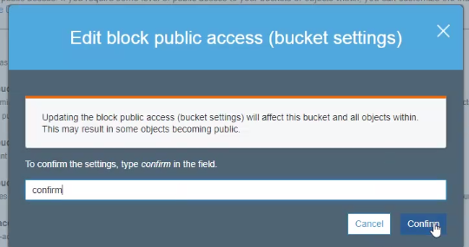
   8. 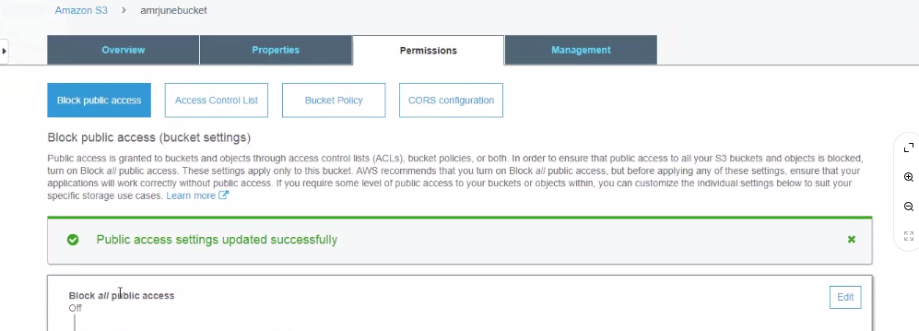

Day 4